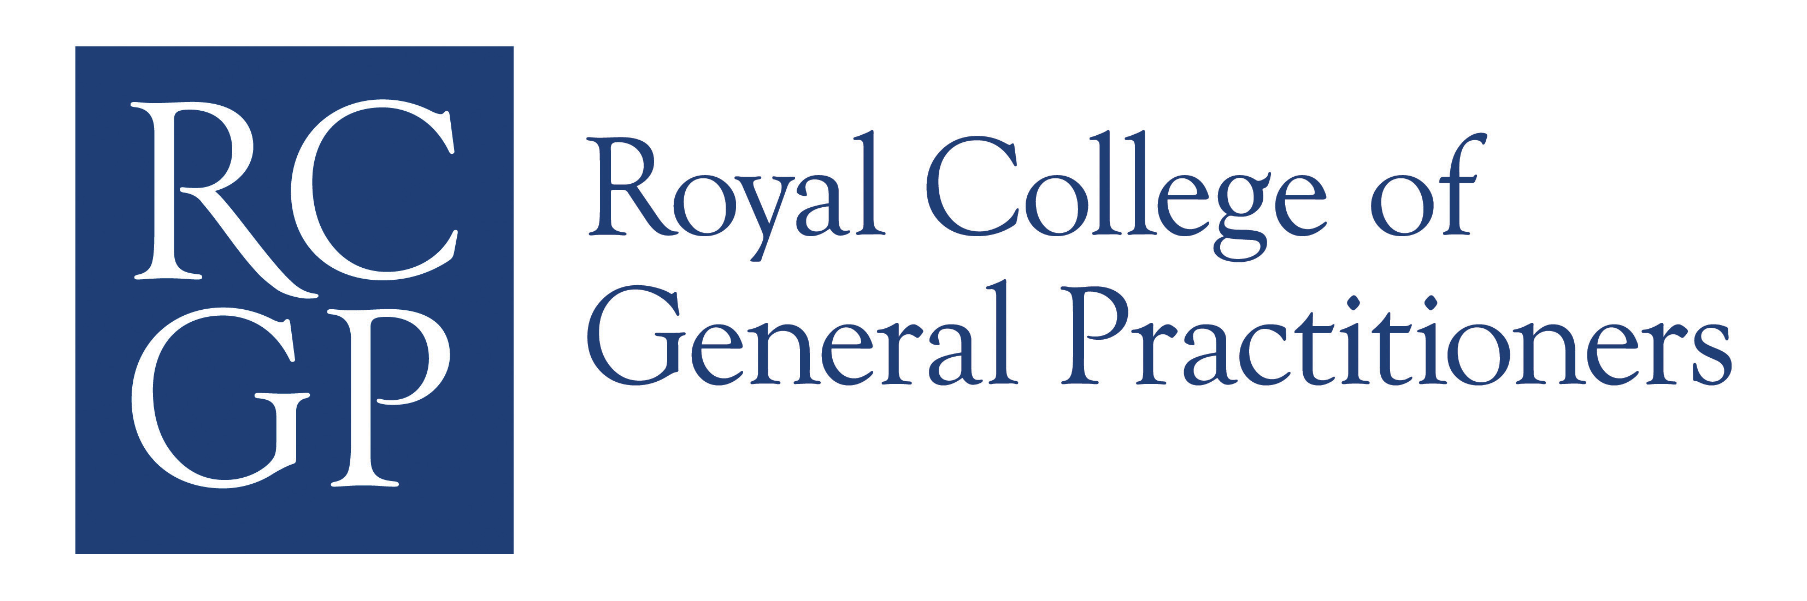

Clinical Skills Assessment

Candidate feedback: suggestions for improvement

How to use the feedback

After your Clinical Skills Assessment you will be informed of your performance overall and your grades for the twelve cases. This is the ‘summative’ part of the feedback. In addition, you will also receive ‘formative’ feedback, which is designed to help you to reflect on possible areas for improvement.

Formative feedback is given in relation to 16 areas of performance (see below). Not all of these are tested in every consultation although they will be tested across the assessment as a whole. Assessors mark each case and then indicate any areas in which they felt your performance was deficient. Any area of performance identified as deficient by two or more assessors will be flagged in feedback as an area for improvement.

You may therefore assume that any area of performance not flagged in feedback was identified as deficient by fewer than two assessors, perhaps none.

How might these results be interpreted?

- Firstly, feedback is generated in an entirely different and separate way from the grades for the cases. Additionally, feedback is given for the assessment overall, not for each case. It is therefore not appropriate to equate feedback with results either by case or overall.
- Feedback is intended to be developmental, so all candidates, including those who pass, may be able to learn from it.
- Where you have had feedback that identifies areas for improvement, try to put this in context by asking yourself ‘How does this compare to what I know of my performance, for example from workplace based assessment?’
- Then read the text below and, where improvement is needed, look closely at the suggestions that are offered.

Feedback statements

Data Gathering

- Disorganised and unsystematic in gathering information from history taking, examination and investigation

Assessors felt that your ability to gather the information required to make a diagnosis or develop a management plan was inadequate.

Suggestions:
Gathering information requires you to be appropriately selective in the questions you ask, the tests you request and the examinations you choose to undertake. You may feel that it would be better to be “on the safe side” by ordering a battery of tests and whilst understandable, this is not good practice and will make you appear indiscriminate. Likewise, history taking and examination is not expected to be all-inclusive and should be tailored to the circumstances and include psychosocial factors where relevant.

Practise these skills in consultation by having a mental approach of being selective and then explaining to the patient what you are doing and why. This is good for patient care and will also demonstrate to assessors that you have a clear and systematic approach. Explaining to the patient exactly what further tests (eg blood tests, if appropriate to the case) are going to be necessary for further patient management, helps the assessors know what you are planning to do and why.

- Does not identify abnormal findings or results or fails to recognise their implications

Assessors felt that you did not demonstrate an ability to identify significant findings and act on them appropriately. Issues identified may need to be prioritised. The ability to manage uncertainty and risk is important in this process.

Suggestions:
This is a clinical rather than interpersonal skill and requires you to make sure that you can correctly interpret the significance of test results or the findings of physical and mental state examinations. The abnormal findings will nearly always relate to common or important conditions. When you prepare for the CSA, pay close attention to your ability to assess risk and to pick up on abnormal findings and deal with them safely. Discuss your management with colleagues, asking them to comment particularly on your risk management and safety-netting. Also, take an active part in significant event reviews, look back on Significant Event Analyses relating to clinical errors and see what you can learn.

- Data gathering does not appear to be guided by the probabilities of disease

Assessors felt that your data gathering did not appear to be guided by the probabilities of the likely diagnosis. You should try to apply your theoretical knowledge to the clinical situation and be appropriately selective in your choice of enquiry and/or examination.

Suggestions:
The skill here is to be selective and to demonstrate that you understand what is likely, what is less likely and what is unlikely but important. First make sure that your knowledge-base is up to scratch and then improve your skills by explaining your approach to the patient. For example, explain what you are looking for, what you think the likely diagnosis will be and (where appropriate) what you feel is unlikely but needs to be ruled out.

- Does not undertake physical examination competently, or use instruments proficiently

Assessors felt that you could improve your physical examination skills. You should be able to demonstrate the appropriate and fluent use of instruments.

Suggestions:
Improving these skills is a matter of practice and it pays to spend time developing a systematic method that you can practise over and over again. Before doing so, take advice and make sure that your technique is correct; otherwise you will simply be reinforcing bad habits. Once correct techniques are practised and become fluent, your approach will appear competent and confident to the assessor.

Clinical management

- Does not make appropriate diagnosis

Assessors felt that you failed to make the appropriate diagnosis. You should consider common conditions in the differential diagnosis.

Suggestions:
Making a diagnosis means committing yourself on the basis of the information you have available to you. Make sure that your knowledge-base is adequate and then ensure that when you have made a diagnosis in consultation, you state this clearly and explain it to the patient. If your summary is too vague, the assessor may not be sure that you have made a diagnosis at all.

- Does not develop a management plan (including prescribing and referral) that is appropriate and in line with current best practice

Assessors felt that your management plans were not always appropriate or in line with current best practice.

- Follow-up arrangements and safety netting are inadequate

Assessors felt that follow up arrangements were not adequate.

Suggestions (6 and 7):
Your management plan and follow up arrangements should reflect the natural history of the condition, be appropriate to the level of risk and be coherent and feasible. Possible risks and benefits of different approaches including prescribing need to be clearly identified and discussed. Your knowledge base is important in this area. Using the concept of PUNS and DENs to improve this selectively and discussing the management of cases you have seen with an experienced doctor will help you in these areas.

8. Does not demonstrate an awareness of management of risk and health promotion

Assessors did not feel that you managed risk or health promotion appropriately.

Suggestions:
In order to manage risk appropriately, you should make the patient aware of the relative risks of different approaches. Health promotion requires doctors to demonstrate an awareness of health (rather than just illness) and to be proactive in maintaining the patient’s health. Managing risk and living with uncertainty are key skills in general practice. Your knowledge base is important here, as is your ability to integrate that knowledge with the specific information you have gained about the patient. Try to be aware of health promotion issues and apply these appropriately. The use of computer-generated prompts can sometimes be helpful.

Interpersonal skills

9. Does not identify patient’s agenda, health beliefs & preferences / does not make use of verbal & non-verbal cues.

Assessors did not feel that you showed competence in using listening skills to identify the patient’s agenda, health beliefs or preferences.

Suggestions:
These skills lie at the heart of patient-centred consulting and a number of educational resources will help you to understand the concept. You should prepare by allowing doctors who are skilled in this approach to assess your performance by, for example, rating you on the COT (consultation observation tool) and providing formative feedback.

10. Does not develop a shared management plan or clarify the roles of doctor and patient

Assessors felt that you did not demonstrate the development of a shared management plan.

Suggestions:
This may be improved by responding appropriately to the patient’s agenda and by attempting to involve patients in making decisions regarding their problem. Clarifying the respective roles may involve reaching agreement with the patient as to what will happen next, who does what and when and the conditions (i.e. the timescale and circumstances) for follow-up. There should be a shared understanding before the patient leaves and this can be confirmed by asking the patient to summarise what they have understood.

11. Does not use explanations that are relevant and understandable to the patient

Assessors felt that your explanations were not sufficiently relevant or understandable to the patient.

Suggestions:
In developing this skill, it is important to avoid the use of jargon, to establish the patient’s health beliefs and tailor your explanation to these. Whether or not your explanation has been understood can be checked through non-verbal communication but also (and more explicitly) by asking the patient to summarise.

- Does not show sensitivity for the patient’s feelings in all aspects of the consultation including physical examination

Assessors felt that you failed to show sensitivity to the patient’s feelings.

Suggestions:
Demonstrating interest in and warmth toward the patient and seeking consent for any clinical examination is important. You could improve this skill by asking an experienced colleague to analyse your consultations, concentrating on this aspect of care, and to give you formative feedback. It might be helpful to gather information about what your patients feel about this aspect of your work before and after you have tried to improve these skills.

Global

- Disorganised / unstructured consultation

Assessors did not feel that the consultation flowed, for example that the tasks of the consultation were sufficiently integrated. The consultation may have appeared disjointed or disorganised.

Suggestions:
Using a consultation model and analysing some video consultations might help you develop this. Using skills such as explaining what you are doing and summarising at appropriate times can help to demonstrate a fluent approach.

- Does not recognise the challenge (e.g. the patient’s problem, ethical dilemma etc.)

Assessors felt that you did not demonstrate that you were able to adequately identify such elements as the patient’s problem/agenda or the challenges and appropriate priorities from the doctor’s perspective.

Suggestions:
Being alert to verbal and non-verbal cues and analysing your consultations either on video or in shared surgeries might help you with this. Look closely at your ability to encourage the patient to share his/her thoughts and expectations. Ask an experienced colleague what they thought the issues and priorities in the consultation were and discuss how these compare with yours.

- Shows poor time management

Assessors felt that you showed poor time management during the cases, perhaps taking too long over certain tasks or failing to cover what was thought to be essential.

Suggestions:
Seeing patients regularly in ten minutes and trying to ensure that you remain focussed on the problem presented might help. Try to observe doctors who consult effectively and efficiently and learn how to modify your own approach. This will help you greatly in clinical life as well as in the assessment.

- Shows inappropriate doctor-centeredness

Assessors felt that you were disproportionately doctor-centred, spending too little time on encouraging and assisting the patient to contribute to a shared dialogue between doctor and patient.

Suggestions:
Being doctor-centred is appropriate for certain tasks in the consultation, for example when using closed questions to take a clinical history. The doctor’s agenda, for example gathering data for health promotion, is also important, but the challenge is to achieve an appropriate balance with the patient’s agenda. Practising listening skills and being alert to verbal and non-verbal cues might help develop a more patient-centred style. Patient-centred doctors are responsive to patient preferences and work to develop common ground and a shared understanding. There are many educational resources (books, DVDs of consulting skills etc.) that will help you to achieve this.

